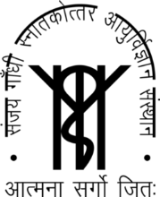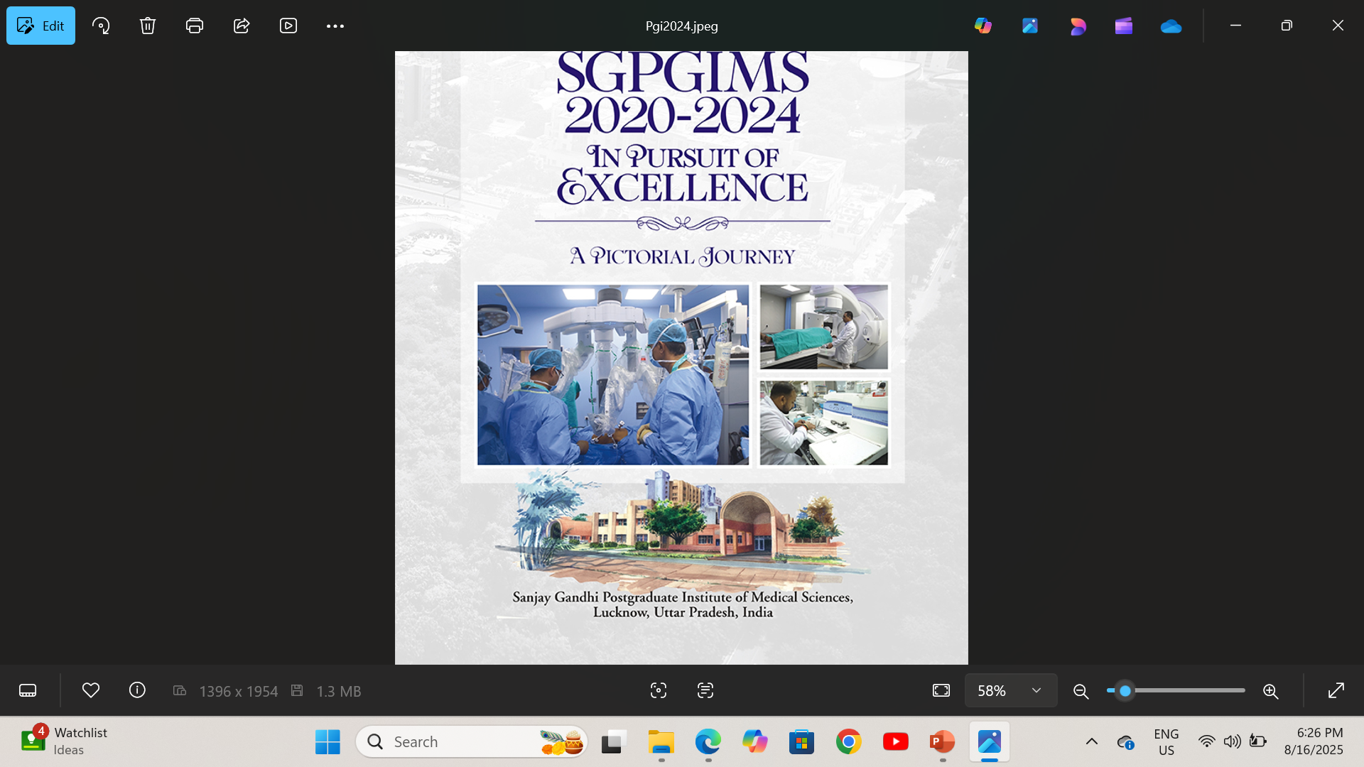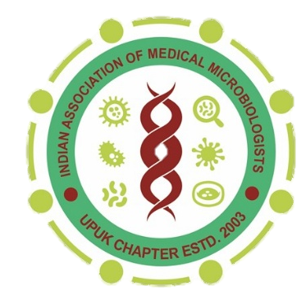
UP-UK MICROCON 2026
For Office Use

Regn. No:
Abstract No:
Receipt date:
Accepted:
Session: Poster / Oral
Date:
21st Annual Conference of UP-UK
Chapter of Indian Association of Medical Microbiologists
Theme - Advances in Clinical Microbiology: Shaping Patient Care

Compulsory details: Membership Number_________________

Registration Number_________________

ABSTRACT FORM

CATEGORY: Oral Presentation  Poster Presentation
Please choose one of the following applicable field:

- Bacteriology
- Mycology
- Mycobacteriology
- Virology
- Serology & Immunology
- Parasitology
- Hospital Infection
- Others (HIV/AIDS, Medical Education, AI, etc)

Applying for which award (Choose anyone)
- Open Awards
- Prof. PC Sen Award on Reserach
- Prof. Archana Ayyagari award on AMR

Designation of Presenter
- Faculty
- Resident
- Research Scholar (PhD/M.Sc/Students)

Title:

Author: (Presenting Author name should be bold and underlined)

Co-Authors:

Institute:

Email of Presenting author:

Abstract should be structured, in Times new roman, font size 12. Maximum 250 words

Introduction:

Materials & Methods:

Results:

Conclusion:

Note : It is mandatory to submit your abstract by email on upukmicrocon2026@gmail.com. Otherwise it will not be considered.

